Product Backlog:

A product backlog is essentially a specialized **to-do** list. It’s an ordered list of tasks, features, or items to be completed as part of a larger product roadmap.

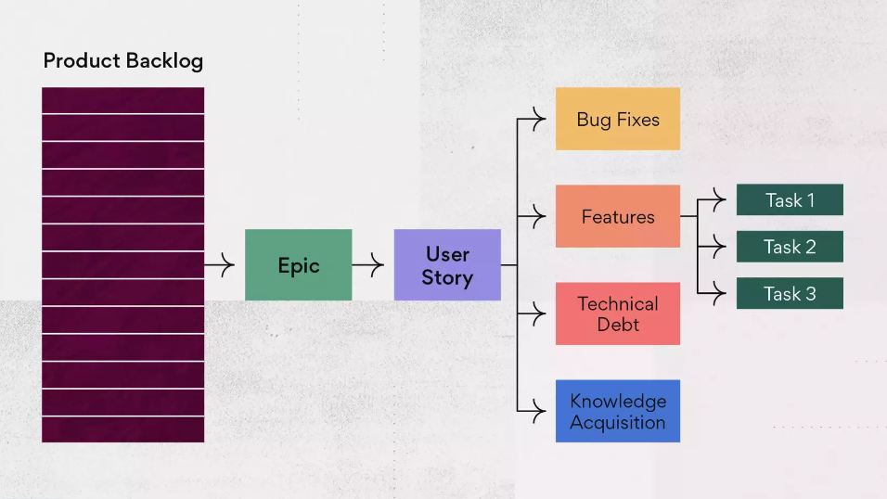

Sprint:

“A sprint is a short and fixed time frame during which a specific set of tasks are meant to be performed”.

Usually, each sprint runs for 2–4 weeks.

A **Sprint Planning Meeting** occurs before the start of every sprint. That meeting defines what set of items could be developed and delivered in the upcoming sprint.

A sprint backlog is the set of items that a cross-functional product team selects from its product backlog to work on during the upcoming sprint.

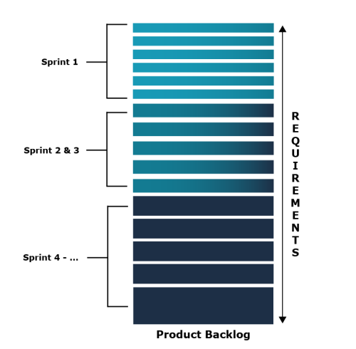

**Sprint roles:**

The task is to divide the workflow into small iterations. Therefore, a sprint team is no different from a scrum team. Thus, a scrum sprint involves 3 roles

Product Owner, Scrum Master and Development Team.

**Product Owner:**

The product owner the face of the organization. He is responsible for all the interaction and communication of the stakeholders by ensuring the right balance among all.

 He tends to decide whether the product needs to be delivered in iterations or continuous delivery.

The product owner guides the development team on what functionalities are assumed to be delivered first and which ones must be given more priority.

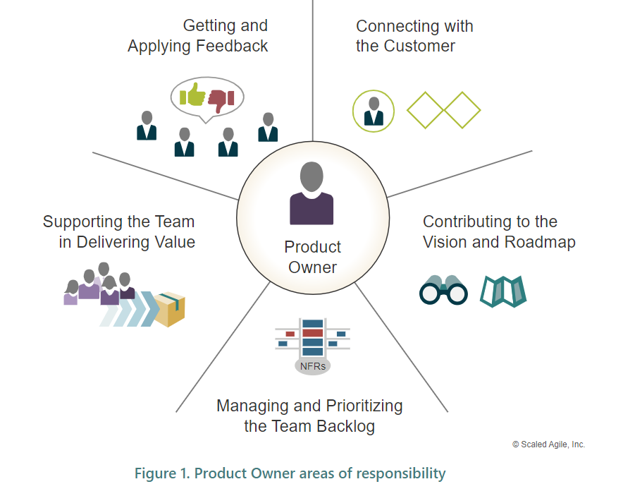

**Scrum Master:**

The scrum master is basically the project manager on the team, who keeps track of individual and overall progress and helps the team achieve maximum efficiency within scrum rules.

The [scrum master](https://www.geeksforgeeks.org/understanding-scrum-master-and-its-roles/) acts as a leader who guides the development team. He facilitates the set of development activities done by the team.

**Development Team:**

The development team consists of software engineers, UX developers, testers, Quality assurance engineers, architects, and business analysts.

**Sprint work flow:**

**Sprint planning meeting:**

**Daily Stand-Up Meetings:**

Every day throughout the sprint, the team members conduct stand-up meetings (also called **Daily Scrum**). The meetings typically last 15 mins and the discussions revolve around all team members.

1. *What I did yesterday?*
2. *Are there any problems I’m facing ?*
3. *What I will do today ?*

### Implementation Phase:

### Every team member works on the set of small tasks he/she is assigned.

### This phase involves Development and Testing. The development is done while prioritizing the functionalities as mentioned by the product owner.

### Sprint Review:

### After the end of each sprint, all the team members present their work to the clients/stakeholders.

### In this meeting, the team gathers review and feedback from the clients and tend to rectify the changes, if any.

### Sprint Retrospective: –

This meeting is held after the sprint review meeting. In this meeting, all the team members including the Scrum Master and Manager discuss the following topics:

*1. The key takeaways from the sprint.*

*2. What things went well and what things didn’t ?*

*3. What problems were faced during the sprint ?*

*4. What other possible decisions could’ve been taken at that point.*

*5. Analysing the merits and demerits faced during the sprint.*